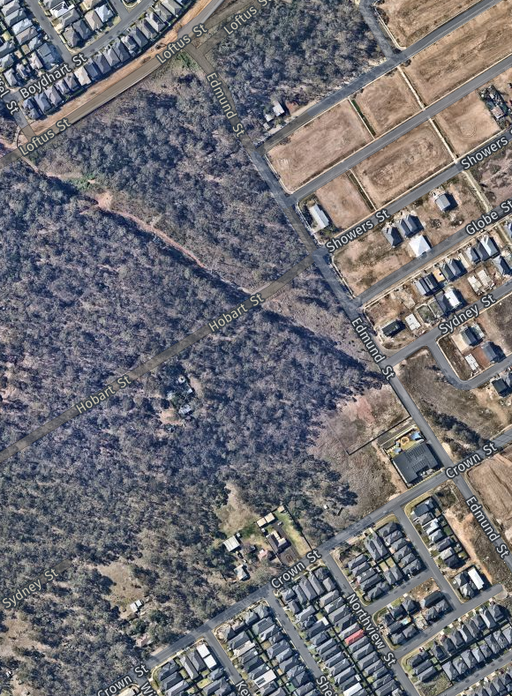


Planning Proposal

Lot 37 Section 17 DP 1480
Sydney Street, Grantham Farm
Rezoning of SP2 Land to R2 Residential

February 2024

Thornleigh
2/1 Central Avenue,
Thornleigh NSW 2120
PO Box 498
Pennant Hills NSW 1715
Phone: +61 2 9980 1000
Email: info@gdsland.com.au
www.gdsland.com.au

Document Control
Client: | Zuela Pty Ltd
Project: | P00608 – Sydney Street, Grantham Farm
Title: | Planning Proposal - Lot 37 Section 17 DP 1480
Town Planner: | Serina Al Abbass

Version: | Prepared by: | Reviewed by:
Internal Review | SA  06/02/2024 | KP  08/02/2024
Client Review | SA  08/02/2024 | OV  08/02/2024
V1 – Submission to Council | SA  12/02/2024 | KP  12/02/2024

Copyright Notice: Group Development Services Pty Limited. The copyright in this work is vested in Group Development Services Pty Limited and the document is issued in confidence for the purpose only for which it is supplied. It must not be reproduced in whole or in part except under an agreement with, or with the consent in writing of, Group Development Services Pty Limited and then only on the condition that this notice appears in any such reproduction. No information as to the contents or subject matter of this document or any part thereof may be given orally or in writing or communicated in any manner whatsoever to any third party without prior consent in writing of Group Development Services Pty Limited.

TABLE OF CONTENT
1. Part 1 - Objectives and Intended Outcomes 1
1.1. Introduction 1
1.2. Objective 1
1.3. Intended Outcomes 2
1.4. Proposed Works Supporting the Planning Proposal 2
1.5. Site Context 2
1.6. Pre-Application Meeting 3
1.7. Future Proposed Development 3
1.8. Supporting studies 5
1.8.1. Concept Engineering Design 5
1.8.2. Bushfire Impact Assessment 5
1.8.3. Contamination Assessment 5
2. Part 2 – Explanation of Provisions 6
2.1. Amendments to State Environmental Planning Policy (Precincts – Central River City) 2021 6
2.2. Proposed Amendments to SEPP Mapping 7
3. Part 3 – Justification of Strategic and Site-Specific Merit 8
3.1. Matters of Consideration 8
4. Part 4 – Mapping 15
5. Part 5 – Community Consultation 15
6. Part 6 – Project Timeline 15
7. Conclusion 16

Tables
Table 1. Appendices Table 1
Table 2. Explanation of Provisions. 6
Table 3. Amendments to Mapping 7
Table 4. Consistency with relevant SEPP's. 10
Table 5. Section 9.1 Ministerial Directions 11

Figures
Figure 1. Aerial Image of Site. Site outlined in red. 3
Figure 2. Future Intended Lot Layout Post Planning Proposal 4
Figure 3. Proposed Subdivision Plan to be submitted under a DA in conjunction with Planning Proposal. 4

Part 1 - Objectives and Intended Outcomes

Introduction
Group Development Services Pty Ltd (GDS) has been commissioned by Zuela Pty Ltd (The Proponent) to prepare this Planning Proposal for the rezoning of Lot 37 Section 17 in Deposited Plan 1480, located along Sydney Street, Grantham Farm (the Site), from SP2 Infrastructure (Drainage) to R2 Low Density Residential.
The proposed zoning amendments will subsequently require amendments to the State Environmental Planning Policy (Precincts – Central River City) 2021 – Appendix 7 Alex Avenue Riverstone Precinct Plan 2010 to facilitate future residential development of the Site. Specifically, amendments to the Land Use Map, Zoning Map, Residential Density Map, Height of Building Map and Land Reservation Acquisition Map.
This Planning Proposal has been prepared in accordance with division 3.4 of the NSW Environmental Planning and Assessment Act 1979 (The Act) and the NSW Department of Planning Housing and Infrastructure ‘Local Environmental Plan Making Guide’.
The following Plans and reports have been submitted to support the submission of this Planning Proposal.
Table 1. Appendices Table
Appendix A - PP Engineering Concept Design REV A (12/02/2024), Prepared by Group Development Services Pty Ltd (Drawing number P00608-CI-PP-1101)
Appendix B - Pre- Application Meeting Advice, Provided by Blacktown City Council (PAM Number: C23/37440)
Appendix C – Future Indicative Lot Layout REV A (16/01/2024), Prepared by Group Development Services Pty Ltd (Drawing Number P00608-SUBDIV-0003)
Appendix D - Bushfire Risk Hazard Assessment V3.1 (13/02/2024), Prepared by Statewide Bushfire Consulting Pty Ltd
Appendix E - Detailed Environmental Site Assessment (09/01/2024), Prepared by Integral Environmental Solutions Pty Ltd

Objective
The objective of this Planning Proposal is to amend appendix 7 of the State Environmental Planning Policy (Precincts—Central River City) 2021 for the rezoning of the subject Site from SP2 Infrastructure (Drainage) to R2 Low Density Residential, by redirecting the drainage catchment and removing the need for the SP2 zoned land, allowing for the provision of housing needs to the community within a low-density residential environment consistent with the planning outcomes for this locality.
The removal of the SP2 Infrastructure does not propose to impact any other surrounding properties. The proposed works will remove the need for Council to maintain additional infrastructure in the future.

Intended Outcomes
- To rezone the Site from SP2 Infrastructure to R2 Low Density Residential.
- To better utilise the Site in an orderly manner.
- To redirect drainage to the local SP2 Drainage away from direct frontage to dwellings.
- Maintain objectives of surrounding R2 Zoning through the creation of additional dwelling entitlements.

Proposed Works Supporting the Planning Proposal
It is proposed under this application to rezone the Site from SP2 Infrastructure (Drainage) to R2 Low Density Residential by removing the need for the proposed drainage reserve over the Site. In support of this, a Concept Engineering Plan prepared by GDS has been submitted in accordance with Blacktown City Council’s Engineering Guide (Appendix A), that demonstrates the proposed stormwater catchment design will support the removal of the infrastructure zoning. It is demonstrated that the engineering and drainage issues are able to be managed in an acceptable way, noting there are no adverse impacts on adjoining properties and their future development potential.
The submitted plans outline the future development potential of both the Site and surrounding lots, being lots 36-44/17/DP 1480. The removal of the SP2 Infrastructure does not propose to impact the future drainage of any other surrounding properties. The design of the pipes have all been sized appropriately to cater for the redirected upstream catchment. The proposed drainage works solution will remove the need for Council to maintain additional infrastructure in the future on this lot.

Site Context
The Site is situated within the Riverstone Precinct as part of the North West Growth Centre and is currently zoned SP2 Infrastructure (Drainage). The Site is rectangular in shape and has an approximate frontage to Sydney Street of 9m and a depth of approximately 60m.
The Site currently contains minor scattered vegetation and is mostly flat with a minor slope towards Edmund Street. An aerial image of the Site is provided in Figure 1 below.

The land immediately surrounding the Site currently retains a vegetated characteristic despite the recent rezoning under the SEPP - Sydney Region Growth Centres 2006, now known as the SEPP (Precincts-Central River City) 2021. The north of the Site is intended as a future Conservation Zone. Parcels of land within the vicinity of the Site are undergoing significant land clearing with extensive subdivision works completed or nearing completion, including a newly constructed and operational Childcare Centre to the south of the Site.

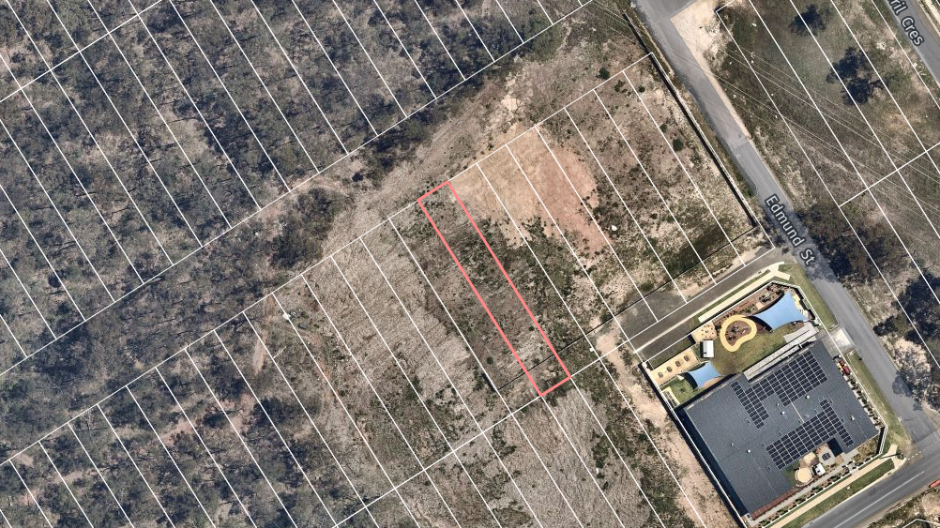
Pre-Application Meeting
Figure 1. Aerial Image of Site. Site outlined in red.
A Pre-Application meeting was held with Blacktown City Council on 31 August 2023 (PAM Number: C23/37440). Council provided feedback to be addressed prior to the submission of the Planning Proposal. Council’s advice, along with our comments on compliance can be found in Appendix B submitted with this PP application. In response to Council’s advice, GDS submitted a draft Engineering Concept Design Set on 22 December 2023, for review by Blacktown City Council. The plans were considered acceptable and feasible, and it was advised by Council that the submission of a Planning Proposal could be supported.

Future Proposed Development
The future intention of the Site upon approval of this Planning Proposal is the subdivision of the Site, along with neighbouring sites (lots 36-44 Section 17 DP 1480) into 17 residential Torrens title lots.
It is proposed that the Site would be better used for residential Development given the capability for drainage around the area to be redirected to Edmund Street and into the future Basin located at Loftus Street north of the Site.
A DA is proposed to be submitted in response to this Planning Proposal for the development of the neighbouring lots 36, 37- 44 Section 17 DP 1480. The subject Site relating to this Proposal will be included in the DA and proposed as a residue lot until such time the Site is rezoned. In the instance the Site is rezoned, the residue lot created will be proposed to be developed under a separate application. The indicative lot layout proposed once the Site is rezoned is per the Future Indicative Lot Layout Plan shown in figure 2 and submitted with this application as Appendix C. The Subdivision Plan proposed to be submitted under a separate DA in conjunction with this Planning Proposal is shown in figure 3.

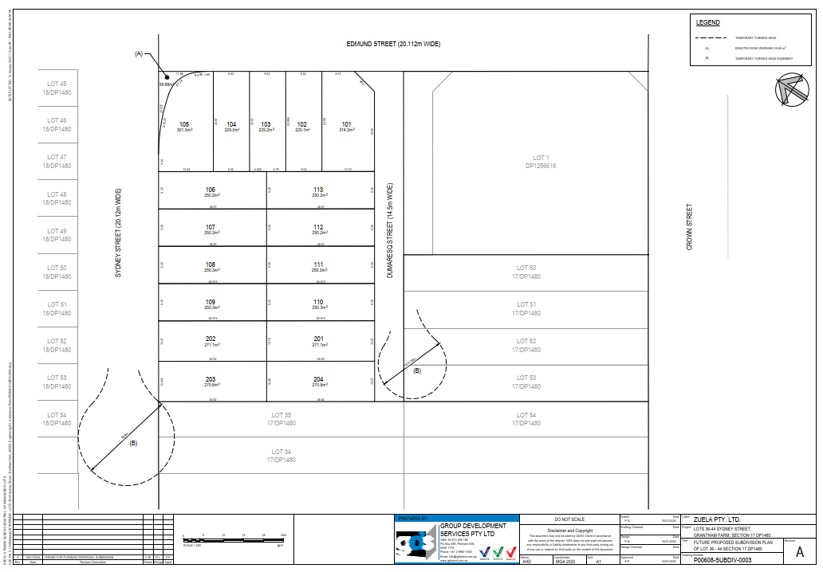
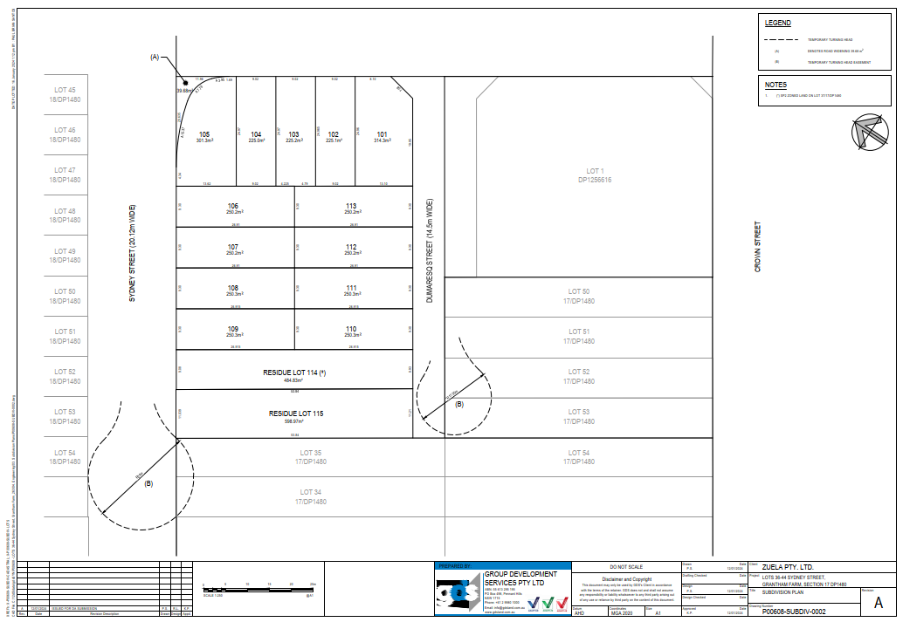
Figure 2. Proposed Subdivision Plan to be submitted under a DA in conjunction with Planning Proposal.
Figure 3. Future Intended Lot Layout Post Planning Proposal

Supporting studies

Concept Engineering Design
GDS has prepared and submitted a Concept Engineering Design set in accordance with Council’s Engineering Guidelines. It supports the proposed rezoning of the Site and demonstrates that the redirection of the catchment is a suitable solution to negate the need for the Site to be utilised as an SP2 Infrastructure area for drainage and can thus be repurposed as a residential zoned land (R2 Low Density Residential).
As outlined in the submitted set, it is proposed to redirect the catchment, which is currently intended to be drained towards the Site, towards Edmund Street through proposed stormwater drainage constructed in Dumaresq Street, instead. The designs show all pipes are appropriately sized to cater for this redirection, and the use of temporary headwalls have been proposed to capture the upstream overland flow, until such time the adjoining properties develop and connect their stormwater drainage network to replace the temporary pipe and headwall. The proposed works will remove the need for Council to maintain additional infrastructure that would be located on the Site in the future and will ensure a more maintained development.

Bushfire Impact Assessment
A Bushfire Impact Assessment has been conducted in support of this Planning Proposal to address the surrounding bushfire affectations, and to assess the Site against relevant bushfire legislation under the Ministerial Directions for Planning Proposals. The Bushfire Assessment has addressed each relevant item under the Ministerial Directions including assessing the Site against section 3.34 of The Act and Planning for Bushfire Protection 2019 and supports the submission of this Planning Proposal. The bushfire Impact Assessment is submitted with this Planning Proposal as Appendix D.

Contamination Assessment
A Detailed Environmental Site Assessment (DESA) was conducted over the Site by Integral Environmental Solutions Pty Ltd to assess any likelihood of contaminants, and to assess the suitability of residential development being proposed. It was concluded in the assessment that the contaminant concentrations from the samples taken were below the threshold concentration, and therefore the Site is deemed suitable for residential development. The DESA is submitted with this Planning Proposal as Appendix E.

Part 2 – Explanation of Provisions

Amendments to State Environmental Planning Policy (Precincts – Central River City) 2021
This Planning Proposal seeks to amend the State Environmental Planning Policy (Precincts – Central River City) 2021 – Appendix 7 Alex Avenue Riverstone Precinct Plan 2010 to facilitate future residential development. The intended provisions are detailed in table 1 below.
Table 2. Explanation of Provisions.
Development Standard to be amended |  | Proposed Amendment
Land Use Zone | SP2 Infrastructure (Drainage) | Amendment to the Land Zoning Map – Sheet LZN_004 to rezone the Site to R2 Low Density Residential consistent with surrounding land use.
Residential Density | N/A | Amendment to the Residential Density Map Sheet RDN_004 to propose density band O1 (15 dwellings per hectare) consistent with surrounding residential density.
Building height | N/A | Amendment to the Height of Buildings Map – Sheet HOB_004 to propose 9m building height consistent with surrounding land.
Land Reservation Acquisition | Local Drainage (SP2) | Amendment to the Land Reservation Acquisition Map –Sheet LRA_004 to remove SP2 Local Drainage mapping from the site.

Proposed Amendments to SEPP Mapping
The existing SEPP controls and proposed amendments to the relevant maps have been outlined in table 2 below. The Site is outline in blue.
Table 3. Amendments to Mapping
Map to be Amended | Existing Map | Proposed Map
Land Zoning Map – Sheet LZN_004 | 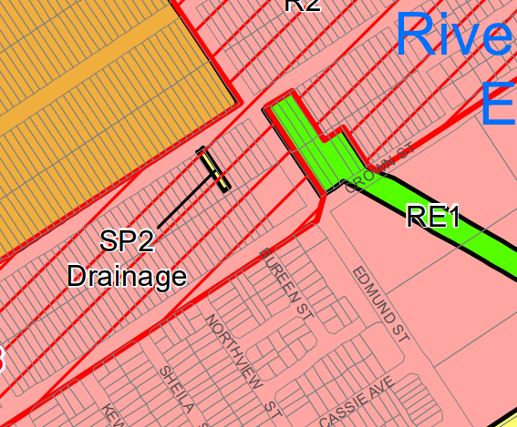 | 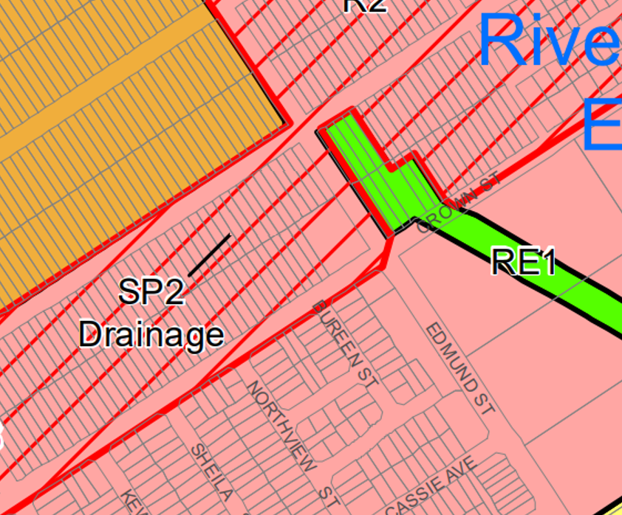
Residential Density Map Sheet RDN_004 | 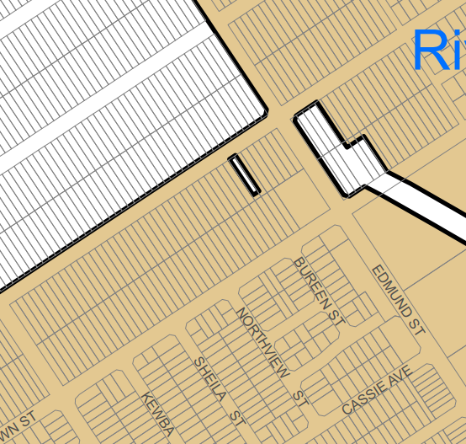 | 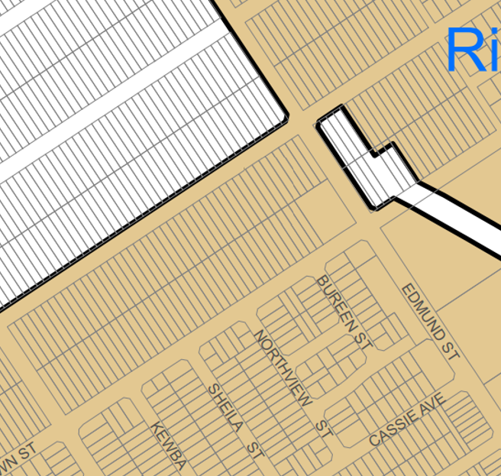
the Height of Buildings Map – Sheet HOB_004 | 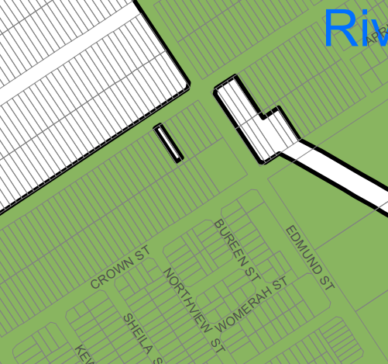 | 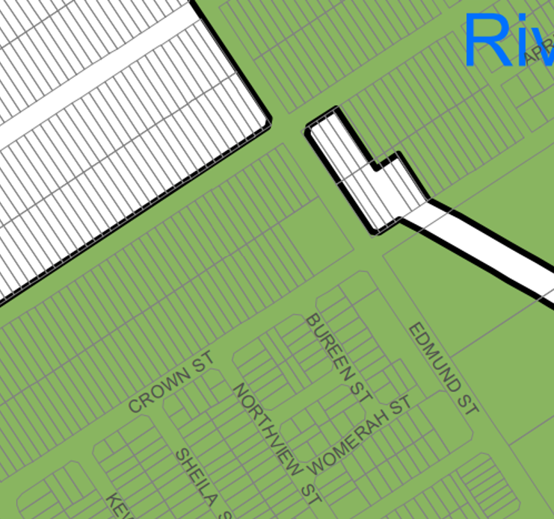
Land Reservation Acquisition Map –Sheet LRA_004 | 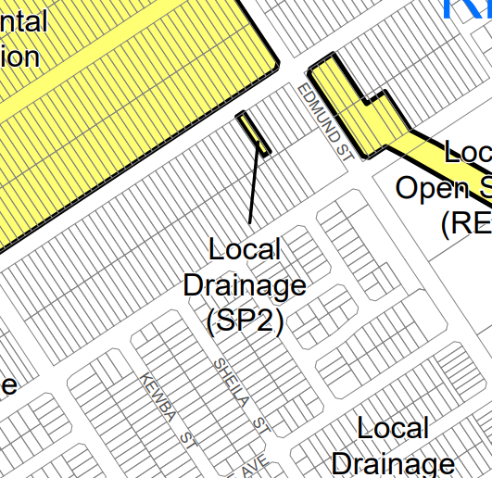 | 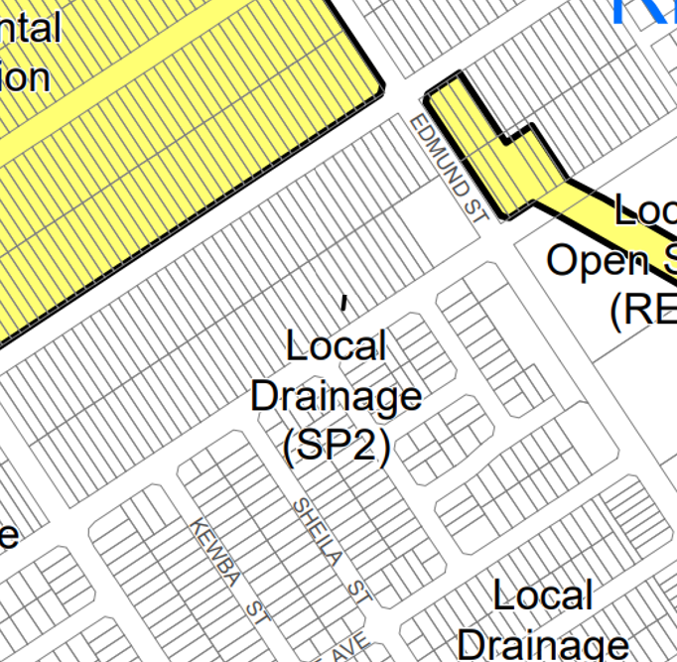

Part 3 – Justification of Strategic and Site-Specific Merit
This section provides a detailed assessment for the proposed amendments to SEPP (Precincts – Central River City) 2021 – Appendix 7 Alex Avenue Riverstone Precinct Plan in accordance with Section 2.3 of ‘Local Environmental Plan Making Guidelines’.

Matters of Consideration
Section A – Need for the Planning Proposal
- Is the planning proposal a result of an endorsed LSPS, strategic study or report?
No. There is no endorsed strategic Planning document linked directly to this Planning Proposal. This Planning Proposal is the result of a drainage assessment and report conducted by GDS Pty Ltd, commissioned by The Proponent, which demonstrates that an alternative underground drainage system can be installed which would be as effective in maintaining stormwater drainage, as well as utilising the Site in an efficient and consistent manner to the surrounding residential zoned land.
- Is the planning proposal the best means of achieving the objectives or intended outcomes, or is there a better way?
Yes, the Planning Proposal is the best means and only way of achieving the planning objectives which is to rezone the Site and amend the relevant planning controls and mapping relating to maximum building height, land zoning, land acquisition and residential density.
Section B – Relationship to the Strategic Planning Framework
- Will the planning proposal give effect to the objectives and actions of the applicable regional or district plan or strategy (including any exhibited draft plans or strategies)?
Yes, the Planning Proposal gives effect to the objectives and actions of the following plans and policies:

Greater Sydney Region Plan - A Metropolis of Three Cities
The Greater Sydney Region Plan, A Metropolis of Three Cities, draws on a vision of Greater Sydney as a metropolis of three cities where most people live within 30 minutes of jobs, education and health facilities, services and great places. The Plan proposes a Metropolis of three unique but connected cities – Western Parkland City, Central River City and Eastern Harbour City.
The Site is within the Central River City Precinct and the proposed development is consistent with the vision of this Precinct, specifically, liveability and housing supply. The Planning Proposal meets objective 10 (Greater housing supply) and 11 (Housing is more diverse and affordable), by utilising the Site for residential development.
- Central City District Plan
The Central City District Plan is a 20-year plan to manage growth in the context of economic, social and environmental matters to achieve the 40-year vision for Greater Sydney. It is a guide for implementing the Greater Sydney Region Plan, A Metropolis of Three Cities, at a district level and is a bridge between regional and local planning. The Planning Proposal is consistent with the direction of Housing the City and planning priority C5, providing housing supply, choice and affordability with access to jobs, services and public transport.
- Is the planning proposal consistent with a council LSPS that has been endorsed by the Planning Secretary or GCC, or another endorsed local strategy or strategic plan?
The Blacktown Local Strategic Planning Statement 2020 (LSPS) sets out a 20-year vision for the future of Blacktown City as it grows and changes. It provides the basis for strategic planning in Blacktown City having regard to economic, social, and environmental matters. The LSPS sets out planning priorities and actions that are consistent with the Greater Sydney Region Plan, Central City District Plan and the Blacktown Community Strategic Plan. The Planning Proposal is consistent with the liveability priorities, specifically, C5 providing housing supply, choice, and affordability with access to jobs, services and public transport, by proposing to provide additional housing supply.
- Is the planning proposal consistent with any other applicable State and regional studies or strategies?
The planning proposal is also consistent with the Housing 2041 Strategy produced by the NSW Department of Planning and Environment. This proposal aims to provide more diverse, suitable, and affordable housing options across the state with a strong aim on affordability and providing housing for the growing youth population (first home buyers). The proposal, which aims to change land zoning from SP2 Drainage to R2 Low Density Residential will allow for the development of a diverse range of housing options consistent with the permitted development types as per the LEP.
- Is the planning proposal consistent with applicable SEPPs?
The Planning Proposal is consistent with the below State Environmental Planning Policies (SEPP):
- SEPP (Precincts – Central River City) 2021
- SEPP (Resilience and Hazards) 2021
- SEPP (Housing) 2021
Table 3 below highlights the consistency with the applicable SEPPs.
Table 4. Consistency with relevant SEPP's.
State Environmental Planning Policy (SEPP) | Overview of Relevant SEPP | Consistency with Planning Proposal
SEPP (Precincts – Central River City) 2021 | This policy aims to establish regulations to guide the sustainable development within the North West Growth Centres. It aims to guide the development of vibrant, diverse, and liveable neighbourhoods while increasing economic growth and thriving local economies. The Site is mapped within the Central River City Precinct and therefore this SEPP is the key EPI applying to the Site. | Consistent.  The Planning Proposal seeks to change the use of land from SP2 Drainage to R2 Low Density Residential zoning. This will allow for additional low-density residential development which will promote liveable, vibrant neighbourhoods, consistent with the aims of this SEPP. The future proposed lots that are intended to be developed if this Planning Proposal is approved, will be able to maintain consistency with the objectives of this SEPP and are able to comply with the controls under Appendix 7 of the SEPP. An Indicative Lot Layout has been submitted with this application as Appendix C to show that the future proposed lots will be able to comply with the relevant controls.
SEPP (Resilience and Hazards) 2021 | The policy aims to provide statewide legislation guiding the reduction of inappropriate and hazardous development, with a focus on coastal communities and marine areas.  It requires the consent authority to consider if remediation work is required for rezoning or building works, and ensures that the subsequent remediation works are satisfactory with respect to standards and notification requirements | Consistent.  The subject Site was assessed for contamination and is deemed suitable for residential development and can accommodate compliance with this Policy, specifically Chapter 4 Remediation of Land. The detailed assessment can be found in Appendix E.
SEPP (Housing) 2021 | The policy includes statewide provisions for affordable housing options as well as social housing and alternative forms of living such as caravan parks and manufactured housing estates. | Consistent.  With the planning proposal aiming to change the zoning of the Site from SP2 Drainage to R2 Low Density Residential, it allows for the creation of additional affordable housing within a low-density residential environment, in line with this SEPP. By providing additional dwellings, the future development will further contribute to affordable housing and alternate forms of living.

- Is the planning proposal consistent with applicable Ministerial Directions (section 9.1 Directions) or key government priority?
The Planning Proposal is consistent with the relevant directions of Section 9.1 Ministerial Directions; This is demonstrated in detail in Table 4 below.
Table 5. Section 9.1 Ministerial Directions
Direction | Comment
Focus area 1: Planning Systems
1.1 Implementation of Regional Plans | Not applicable to Planning Proposal.
1.2 Development of Aboriginal Land Council land | Not applicable to Planning Proposal.
1.3 Approval and Referral Requirements | This Planning Proposal seeks to minimise the inclusion of provisions that require the concurrence, consultation or referral of a development application to a Minister or public authority, with the exception of referral to the RFS given the Site is on bushfire prone land. A Bushfire Impact Assessment is submitted with this PP to address the bushfire regulations.  The Planning Proposal does not identify the development as designated development.
1.4 Site Specific Provisions | The Planning Proposal is for the rezoning of SP2 Land to R2 land, however, does not propose any site specific provisions.  The R2 Low Density Residential standard LEP zoning requirements will apply to the site if the PP is approved.
1.6 Implementation of North West Priority Area Land Use and Infrastructure Implementation Plan | The planning proposal is consistent with the North West Priority Growth Area Land Use and Infrastructure strategy by providing a diverse range of housing with accessibility to community facilities, roads and public transport and coordinating the redirection of drainage infrastructure to support this housing range.
1.10 Implementation of the Western Sydney Aerotropolis Plan | Not applicable – while this direction applies to Blacktown City Council, the subject Site is not included in the precinct boundary of the Western Sydney Aerotropolis.
Focus area 3: Biodiversity and Conservation
3.1 Conservation Zones | The Planning Proposal Site is not within a Conservation Area.
3.2 Heritage Conservation | The Planning Proposal Site is not within a LEP mapped European Heritage Area. Aboriginal Heritage will be assessed at the DA stage. It is noted that there is 1 Aboriginal site recorded near the Site located along Hobart Street within the Conservation Zoned Land. An AHIMS Search has been submitted with this application for reference.
3.3 Sydney Drinking Water Catchments | Not applicable to Planning Proposal. While this direction applies to Blacktown City Council, the Site is not located within a Sydney Drinking Water Catchment.
3.5 Recreation Vehicle Areas | Not applicable to Planning Proposal.
3.6 Strategic Conservation Planning | The Site is not mapped with avoided land identified in SEPP (Biodiversity and Conservation) 2021. The Site is bio certified under Part 8 of the Biodiversity and Conservation Act 2016.
3.7 Public Bushland | The Site is bio certified under Part 8 of the Biodiversity and Conservation Act 2016. The Site also fronts land zoned for Environmental Conservation intended to be the protected bushland within the urban precinct.
3.10 Water Catchment Protection | Not applicable to Planning Proposal. The Site is not within a Regulated Catchment.
Focus area 4: Resilience and Hazards
4.1 Flooding | The Site is not mapped as flood prone land.  The drainage design solution will not result in any flood or overflow impacts to the locality. The drainage of stormwater and overland flow will be managed via an alternate system as demonstrated under this Planning Proposal.
4.3 Planning for Bushfire Protection | The Site is mapped as bushfire prone land, specifically Vegetation Category 1. A Bushfire Impact Assessment has been prepared and submitted with this PP as Appendix D to address the bushfire impacts across the Site for future development, in accordance with this objective. The Planning Proposal is consistent with the objectives of direction 4.3 and will refer to ‘Planning for Bush Fire Protection 2019’ guidelines by the NSW RFS.
4.4 Remediation of Contaminated Land | The Site has been assessed for contamination and any remediation will be conducted during DA stage as required per Chapter 4 of SEPP (Resilience and Hazards) 2021, and as addressed in Appendix E.
4.5 Acid Sulfate Soils | Not relevant to Planning Proposal. The site is not mapped as Acid Sulfate land.
4.6 Mine Subsidence and Unstable Land | Not relevant to Planning Proposal.
Focus area 5: Transport and Infrastructure
5.1 Integrating Land Use and Transport | The Site is located adjacent to surrounding residential zoned land with existing nearby public transport bus routes along Crown Street and Edmund Street. The Site is also located within close proximity to train stations, being both Vineyard Station and Riverstone Station. The further development of the Site and surrounding sites will further improve the existing public transport by creating additional demand for the services.
5.2 Reserving Land for Public Purposes | This direction restricts planning proposals from altering existing zonings and reservations of land for public purposes without approval from the relevant public authority.  The Planning Proposal seeks the approval from the relevant public authority to remove the requirement for Council to acquire the land for Drainage purposes, and therefore benefitting both Council and allowing future development to take place.
Focus area 6: Housing
6.1 Residential Zones | The Planning Proposal will create additional residential lots that can encourage various forms of accommodation and design. Infrastructure and servicing will be available to all future proposed lots. There is sufficient surrounding provision of open space, community facilities and road infrastructure that support that proposed residential development.

Section C – Environmental, Social and Economic Impact
- Is there any likelihood that critical habitat or threatened species, populations or ecological communities, or their habitats, will be adversely affected because of the proposal?
The Site is mostly clear of vegetation and is not identified as containing any threatened species of flora or fauna. The Site is also Bio Certified as previously addressed. It is not likely the Planning proposal will impact any potential habitat loss nor indirectly impact on threatened species.
- Are there any other likely environmental effects of the planning proposal and how are they proposed to be managed?
It is not anticipated the Planning Proposal will have any significant negative environmental impacts to the Site. The Site will be assessed at the development stage for contamination, heritage and bushfire, and the significance of vegetation on Site will also be assessed. A bushfire Assessment has already been conducted and submitted as Appendix D with this Planning Proposal.
- Has the planning proposal adequately addressed any social and economic effects?
The Planning Proposal will provide a positive social and economic effect by facilitating additional housing supplies within the growth precinct and helping to create diverse and liveable communities.
Section D – Infrastructure (Local, State and Commonwealth)
- Is there adequate public infrastructure for the planning proposal?
There is adequate public infrastructure for the Planning Proposal and any future housing development over the Site. Future DA’s will in time further develop infrastructure and services through demand. The Site will be serviced with full roads, utilities, sewage, drainage and suitable access to public transport along Crown Street and Edmund Street.
The Concept Engineering Design presented for the PP demonstrates the adequate drainage and overflow solution in order to redirect the drainage from the Site to Edmund Street, to remove the need for the SP2 infrastructure Zoning across the Site.
Additional infrastructure servicing requirements will be addressed in any future development applications over the Site.
Section E – State and Commonwealth Interests
- What are the views of State and Federal public authorities and were any government agencies consulted in order to inform the Gateway determination?
Consultation with State and Federal public authorities and government agencies is yet to be undertaken at this stage. Consultation with the relevant authorities will be undertaken as part of the exhibition period of the Planning Proposal as per the Gateway Determination.

Part 4 – Mapping
The Planning Proposal seeks to amend the following maps of SEPP Precincts - CRC 2021 as outlined in part 2 of this report:
- Land Zoning Map Sheet LZN_004;
- Land Reservation Acquisition Map Sheet LRA_004;
- Height of Buildings Map Sheet HOB_004; and
- Residential Density Map Sheet RDN_004.

Part 5 – Community Consultation
Community consultation will be carried out in accordance with the Department of Planning’s Local Environmental Plan Making Guidelines. The Gateway Determination will specify the duration and extent of community consultation that will be required, however, as a Standard Planning Proposal, the recommended exhibition period is 20 days.

Part 6 – Project Timeline
The ‘Local Environmental Plan Making Guideline’ states that one of the aims of the plan making process is to reduce delays to help streamline the process. Consultation with Council is recommended to confirm the timeframe of completion; however, The Proponent seeks to ensure that the Planning Proposal will have a resolution in 2024, consistent with the aims to reduce delays.

Conclusion
This Planning Proposal has been submitted to amend the State Environmental Planning Policy (Precincts – Central River City) 2021 for the proposed rezoning of the subject Site from SP2 Infrastructure (Drainage) to R2 Low Density Residential and subsequent amendment of the Building Height Control Map, the Land Reservation Acquisition Map and Residential Density Map, in accordance with division 3.4 of the NSW Environmental Planning and Assessment Act 1979 and the NSW Department of Planning Housing and Infrastructure ‘Local Environmental Plan Making Guide’.
Concept Engineering Designs have been submitted with this Proposal to support the proposed rezoning and demonstrates that the removal of the intended drainage catchment on the Site can be redirected away from the Site and is a suitable drainage solution that can also be supported by Council. This removal of the drainage catchment allows for the Site to be utilised for residential purposes, and further removes the need for Council to maintain the intended drainage infrastructure.
Based on the Engineering Concept Designs, and the Planning Assessment conducted as part of this Planning Proposal, which has assessed proposal against all the relevant strategic planning policies and statutory planning instruments, being the Greater Sydney Region Plan, Central City District Plan, Blacktown Local Strategic Planning Statement, the Section 9.1 Ministerial Directions and the relevant State Environmental Planning Policies, it is deemed that the rezoning of the Site from SP2 Drainage to R2 Low Density Residential is merited.
The Planning Proposal is submitted to Council for consideration and if supported, the Proposal is intended to be submitted to the Department of Planning Housing & Industry for Gateway determination.


2/1 Central Avenue, Thornleigh NSW 2120
PO Box 498, Pennant Hills NSW 1715
Phone: +61 2 9980 1000
Email: info@gdsland.com.au
www.gdsland.com.au
ABN: 55 613 295 195

